Camp Wrightwood
2021 Rates
Lodging Rates (per person) (Non-COVID-19) |  | Non-Lodging Rates
Minimums |  | Weddings  - $4000  Day Use  - Contact site  Pool Use  - $50/hour; 2 hours minimum  - $25/hour, for groups with lifeguard (Lifeguard MUST bring current certification and valid ID)  Archery  - $40/hour ten person minimum  Ropes Course/Team Building  - Contact site for rates.
Full Camp 100  Lodge 30  Smith Hall 20  Huddle Hut 1  Any 2 areas: minimum 60 | Full Camp 189  Lodge 84  Smith Hall 80  Huddle Hut 25  Any 2 areas (varies as above)
With Meal Service (minimum 20)
1 Night/3 Meals $96.  2 Nights/5 Meals $139.  3 Nights/8 Meals $193. | 4 Nights/11 Meals $245.  5 Nights/14 Meals $298.  6 Nights/17 Meals $349.
Additional Nights with (3) Meals: $58.
Additional Meals: $12.00
Self – Cooking
Smith Hall or Lodge  1 Night $72.  2 Nights $97.  3 Nights $123.  4 Nights $149.  5 Nights $185.  6 Nights $211.  More than 6 nights  Each Additional Night $34 | Huddle Hut (flat rate)  - Without linens  1 Nights $1390.  2 Nights $1800.  3 Nights $2100.  4 Nights $2420.  5 Nights $2720.  Each additional night: $355.  Linen Service  - $15/bed  - Huddle hut only
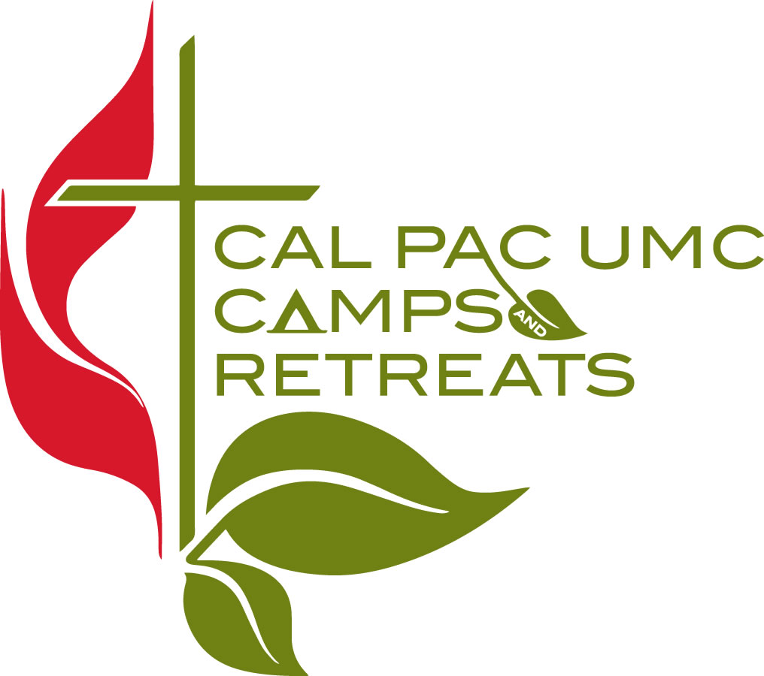
Visit our Websites at : www.calpaccamps.org or www.campwrightwood.com Revised 2/20/2020

