Camp Wrightwood
2023 Rates
Lodging Rates (per person) |  | Non-Lodging Rates
Minimums |  | Weddings  - $4500  - 12-8PM  Day Use  - Contact site  Pool Use  - $50/hour; 2 hours minimum  - $25/hour, for groups with lifeguard (Lifeguard MUST bring current certification and valid ID)  Archery  - $40/hour ten person minimum  Ropes Course/Team Building  - Contact site for rates.
Full Camp 100  Lodge 30  Smith Hall 20  Huddle Hut 1  Any 2 areas: minimum 60 | Full Camp 189  Lodge 84  Smith Hall 80  Huddle Hut 25  Any 2 areas (varies as above)
With Meal Service (minimum 20)
1 Night/3 Meals $109  2 Nights/5 Meals $151.  3 Nights/8 Meals $207. | 4 Nights/11 Meals $265.  5 Nights/14 Meals $320.  6 Nights/17 Meals $375.
Additional Nights with (3) Meals: $65.
Additional Meals: $15.00
Self – Cooking
Smith Hall or Lodge  1 Night $91.  2 Nights $106.  3 Nights $135.  4 Nights $167.  5 Nights $204.  6 Nights $227.  More than 6 nights  Each Additional Night $37 | Huddle Hut (flat rate)  - Without linens  1 Nights $1445.  2 Nights $1875.  3 Nights $2185.  4 Nights $2515.  5 Nights $2830.  Each additional night: $370.  Linen Service  - $15/bed  - Huddle hut only
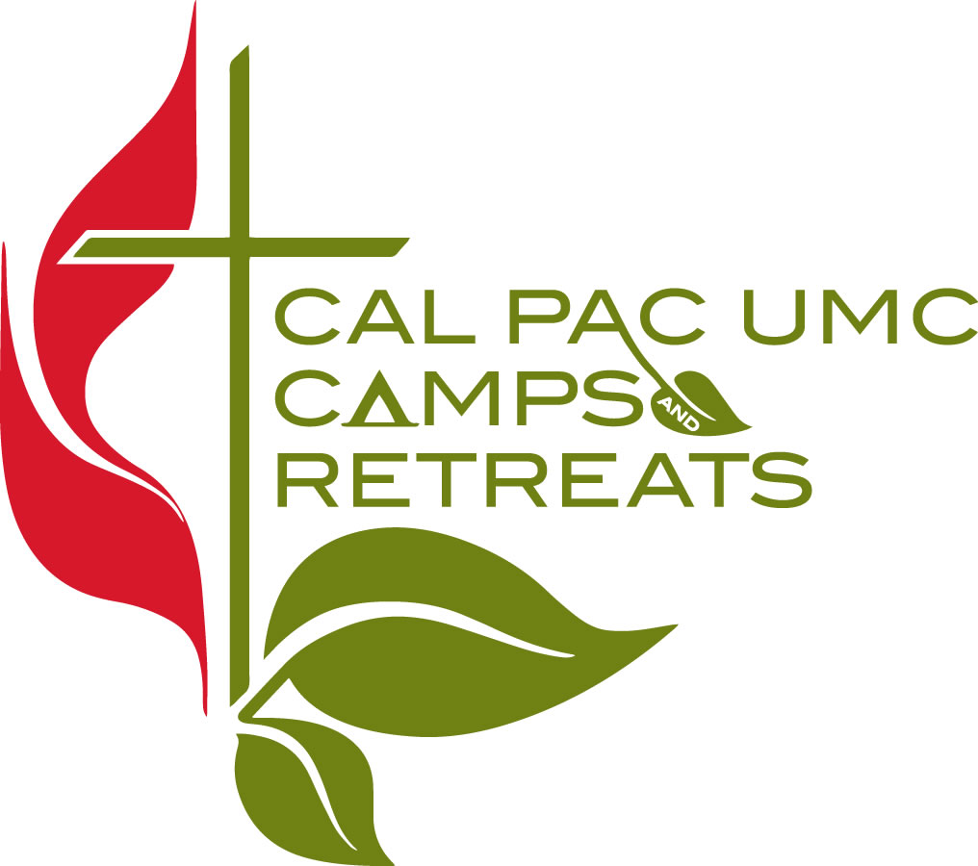
Visit our Websites at : www.calpaccamps.org or www.campwrightwood.com Revised 6/21/22

